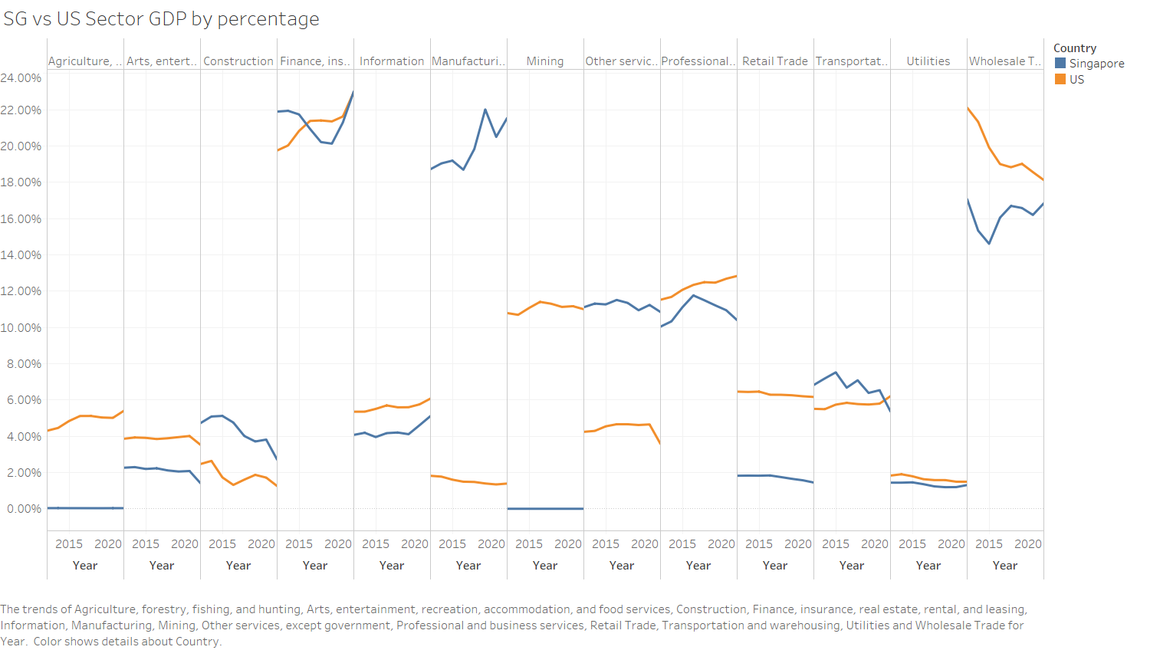

We compare Singapore’s sector GDP against US as US is one of the world’s first developed country. As such US would be considered more advanced in terms of economic growth and development than Singapore. US also have a diverse economy. By looking at the trends between these two countries, we hope to gain some insights as to how the future contribution to GDP by sector looks like for Singapore.

We have obtained publicly available data and grouped them according to following sectors:

* Agriculture, forestry, fishing, and hunting
* Arts, entertainment, recreation, accommodation, and food services
* Construction
* Finance, insurance, real estate, rental, and leasing
* Information
* Manufacturing
* Mining
* Other services, except government
* Professional and business services
* Retail Trade
* Transportation and warehousing
* Utilities
* Wholesale Trade

Sectors such as ‘Agriculture, forestry, fishing, and hunting’ and ‘mining’ can be ignored due to the different kind of natural resources available to each country.

**Arts, entertainment, recreation, accommodation, and food services:**

There is a drop of GDP Contribution by both countries, this might be due to pandemic and it should not be taken at face value.

**Construction:**

Contribution by this sector has been declining. For developed countries, there would not be as much construction as developing countries. We can see US’s contribution is much lower, and it can be used as a good predictor for said industry in Singapore.

Construction related education (such as architecture) can be reduced.

**Finance, insurance, real estate, rental, and leasing:**

Contribution by this sector is on the rise, except for Singapore in 2018. This might be due to rising interest rates around the world and trade wars affecting stock prices. We can see US is not as unaffected. Singapore’s financial and real estate sector might be more susceptible than US’ to global events. However in the years where there is a decline in contribution by Singapore, it is stagnant for US counterparty. It has since bounced back and has been on the rise.

Education in this sector can be increased accordingly.

**Information:**

Information sector is mostly identified with computer programming and system design. There is a steady rise in Singapore and US. It is a larger contributor to GDP for US than Singapore and it can be used as a forecast of what will happen to the same sector in Singapore.

Education in this sector can be increased accordingly.

**Manufacturing:**

Manufacturing industry contributes to more than 20% of Singapore’s GDP and our government do have plans to further grow this industry by going into ‘advanced manufacturing’. As this is the direction by the government, we are unable to advise on whether we should increase or reduce intake based on our data.

<https://www.channelnewsasia.com/news/singapore/singapore-grow-manufacturing-sector-50-percent-2030-14037626#:~:text=Currently%2C%20manufacturing%20accounts%20for%20about,wages%20of%20around%20S%244%2C700>.

**Other services, except government:**

Consistent for both countries, unable to determine graduates from which sector contributes to these and we are unable to advise based on our data.

**Professional and business services:**

This sector has been decreasing in Singapore, however there is a steady rise for US. There might be potential for this sector and the MOE can consider ramping up education in this sector.

**Retail Trade:**

This sector has seen a slow decline. Due to pandemic, technology is accelerated and there is a decrease in retail activities. This will be the direction moving forward as technology grows into a larger part of our lives. Education in this sector can be decreased accordingly.

**Transportation and warehousing:**

There is a decline in transportation for Singapore, compared to increase in US. We are however unable to advise as we are different geographically.

**Utilities:**

This sector is consistent for both countries. It should remain so as it is a staple part of the population’s lives.

**Wholesale Trade:**

Wholesale Trade industry is on the rise for Singapore contrary to US’ decline. As there are initiatives put in place by government to digitalise this sector (<https://www.imda.gov.sg/wholesale-trade-idp>), we might see further growth until Singapore has hit US stage of economy. Education in this sector can be increased accordingly.

**Conclusion:**

**We group the sectors into: Unable to advise, increase resources, decrease resources, or remain unchanged.**

|  |  |  |  |  |  |  |  |  |  |  |
| --- | --- | --- | --- | --- | --- | --- | --- | --- | --- | --- |
| Arts, entertainment, recreation, accommodation, and food services | Construction | Finance, insurance, real estate, rental, and leasing | Information | Manufacturing | Other services, except government | Professional and business services | Retail Trade | Transportation and warehousing | Utilities | Wholesale Trade |
| Unable to advise | Decrease resources | Increase resources | Increase resources | Unable to advise | Unable to advise | Increase resources | Decrease resources | Unable to advise | Remain unchanged | Increase resources |